PREDOCTION THROUGH ARMA ARIMA
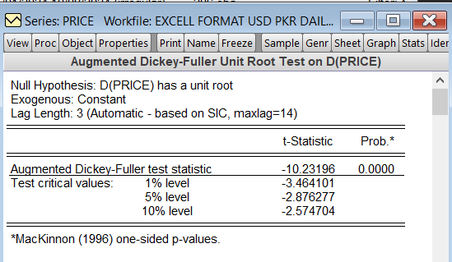

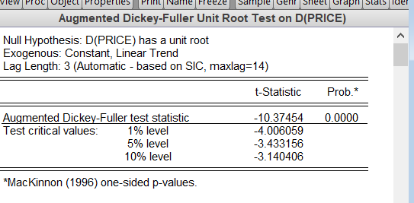

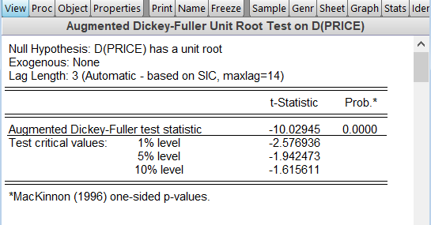
Since on 1st difference all are stationary so we will use ARIMA

ESTIMATING P & Q LAGS

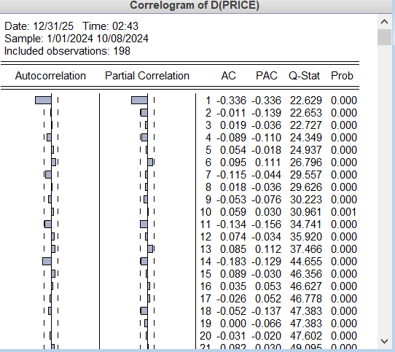

ARIMA (1,1,1)

ESTIMATING MODELS AND SELECTING OPTIMALS
Model 1 (1,1,1)

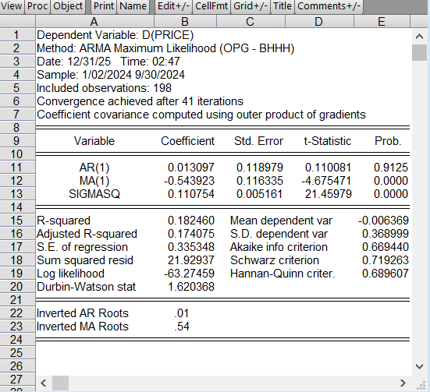

Model 2 (1,1,0)
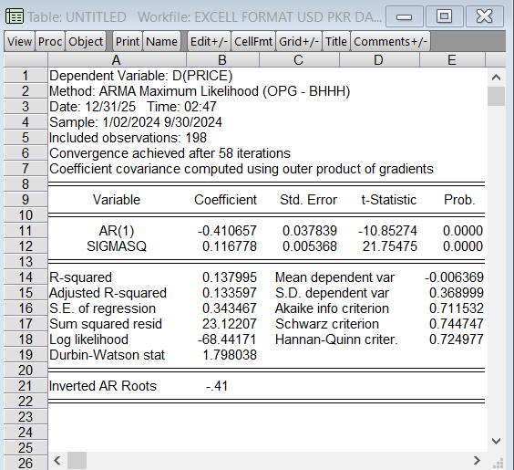

Model 3 (0,1,1)

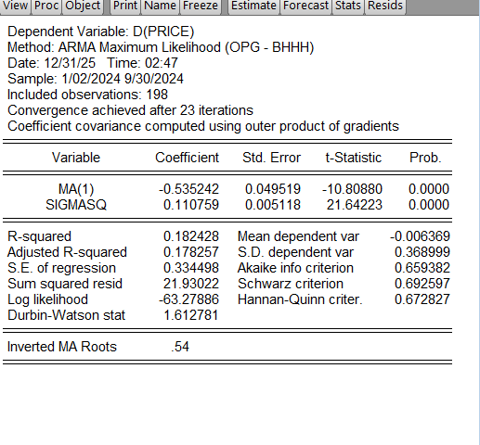

COMPARISON OF MODELS
 | Sig/insig | Sigmasq | R2 | Akaike | Schwarz
Model 1 | 0 | 1 | 1 | 0 | 0
Model 2 | 1 | 0 | 0 | 0 | 1
Model 3 | 1 | 1 | 1 | 1 | 1
Model 3 (0,1,1)

Residuals Diagnostics
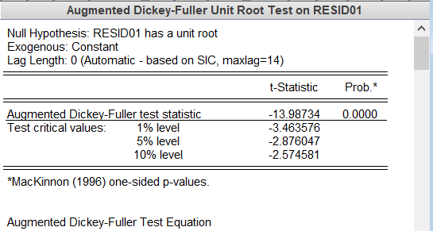

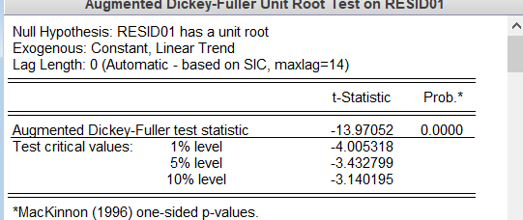

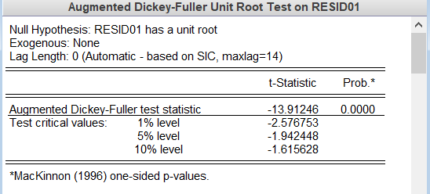

Corellogram of residuals

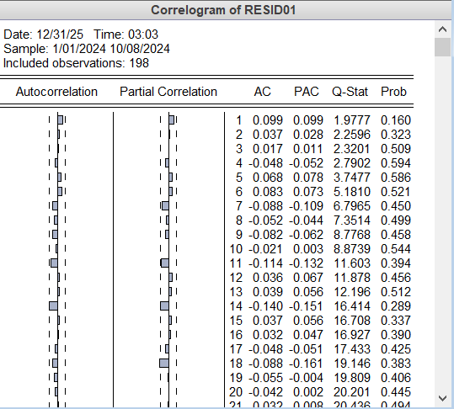

Predictions
